# Registar office Letter header B_W.jpg

# **Smart Water Monitoring and Alerting System**

A Project Report

Submitted in the partial fulfillment of the requirements for the award of the degree of

# Bachelor of Technology in

Department of Electronics & Communication Engineering

By

2210040003 – TAS Vardhan

**2210040017 – Bonthu Namo Sai Reddy**

2210040026 – Balla Pritam

2210040089 – M Vishnu Vardhan Reddy

under the supervision of

# Mrs K Madhavi, Assistant Professor



Department of Electronics & Communication Engineering

K L E F, Off Campus-Hyderabad,

Aziz Nagar- 500075, Rangareddy(Dist), Telangana, India.

August, 2023

**Declaration**

The Project Report entitled “Water monitoring system “is a record of bonafide work of 2210040003, 2210040017, 2210040026, 2210040089, submitted in partial fulfillment for the award of B.Tech in Department of Electronics & Communication Engineering to the K L University. The results embodied in this report have not been copied from any other departments/University/Institute.

2210040003 – T A S VARDHAN

2210040017 – B NAMO SAI REDDY

2210040026 – B PRITAM

2210040089 – M VISHNU VARDHAN REDDY

**Certificate**

This is to certify that the Project Report entitled “Water Monitoring System” is being submitted by 2210040003, 2210040017, 2210040026, 2210040089 submitted in partial fulfillment for the award of B.Tech in Department Of Electronics & Communicaton Engineering to the K L University is a record of bonafide work carried out under our guidance and supervision.

The results embodied in this report have not been copied from any other departments/ University/Institute.

## Signature of the Co-Supervisor (If Available) Signature of the Supervisor

Name and Designation Name and Designation

## Signature of the HOD Signature of the External Examiner

**ACKNOWLEDGEMENTS**

It gives us immense pleasure to convey our gratitude to our honorable President, **Er. Koneru Satyanarayana Sir**, for providing us with the opportunity and a well-equipped platform to successfully complete this project-based laboratory report.

We extend our heartfelt appreciation to our Principal, **Dr. A. RAMA KRISHNA Sir**, for his exceptional administrative support, which has significantly contributed to our academic growth.

We would also like to acknowledge our deep appreciation for **Dr. Goutham Makkena Ph.D.,** our Head of the Department (ECE), for his valuable insights and support throughout this endeavor.

We extend our sincere thanks to our esteemed project supervisors, **Mrs. K. Madhavi** and **Dr. Joshitha C**, for their innovative ideas, unwavering encouragement, genuine appreciation, and intellectual guidance. Their mentorship played a pivotal role in inspiring us to navigate this project to success.

Lastly, we take this opportunity to express our gratitude to all those who directly or indirectly contributed to the success of this project report. Your efforts have been instrumental in its accomplishment.

**Yours Sincerely,**

**2210040003-T A S Vardhan**

**2210040017-B Namo Sai Reddy**

**2210040026-B Pritam**

**2210040089-M Vishnu Vardhan Reddy**

**ABSTRACT**

Access to clean and safe drinking water is essential for the well-being of individuals and communities. However, the quality of water sources can be compromised due to various factors, including pollution, natural contaminants, and infrastructure issues. To ensure the availability of safe drinking water, there is a pressing need for efficient water monitoring systems that can assess water purity in real-time and promptly alert water management authorities in case of contamination. This project introduces a cutting-edge "Smart Water Monitoring System" designed to address this critical issue.

The Smart Water Monitoring System is an integrated solution that combines advanced sensor technology, data analysis, and wireless communication to continuously assess the purity of water sources. The system employs a network of strategically placed water quality sensors capable of measuring a range of parameters, including pH, turbidity, dissolved oxygen, and specific chemical contaminants. These sensors transmit data to a central control unit in real-time, which then processes the information and compares it to predefined water quality standards.

If the system detects any deviations from these standards, signifying a potential contamination event, it immediately triggers an automated alert. This alert is sent to the responsible water management authorities via various communication channels, including SMS, email, and a user-friendly web interface. Water quality data, including the location and severity of the issue, is made available to authorized personnel, enabling them to respond quickly and take appropriate actions to safeguard public health.

This project offers a comprehensive and scalable solution to water quality monitoring and management, with the potential to revolutionize the way we ensure safe and clean water for all. By integrating state-of-the-art technology with water quality standards and timely alerts, it enables proactive responses to water quality concerns, preventing potential health hazards. Furthermore, the system can be adapted and expanded to cover various water sources, from municipal water supplies to remote wells and reservoirs.

The Smart Water Monitoring System represents a significant step towards sustainable and secure access to pure water, protecting the health and well-being of communities worldwide. This report provides an in-depth exploration of the system's design, components, data analysis techniques, and its potential impact on water quality management.

**Table Of Contents**

|  |  |  |
| --- | --- | --- |
| S.No | Content | Page Number |
| 1. | Introduction | 7 |
| 2. | Literature Review | 9 |
| 3. | Theoretical Analysis | 11 |
| 4. | Design and Implementation | 17 |
| 5. | Experimental Investigations | 22 |
| 6. | Experimental Results | 27 |
| 7. | Discussion of Results | 30 |
| 8. | Summary | 35 |

**Introduction**

The introduction section of the project report lays the foundation for understanding the water quality using TDS sensor.

. This section provides essential context and outlines the project's objectives, scope, and significance.

**1.1 Background and Motivation:** Access to clean and safe drinking water is a fundamental human right and a critical component of public health. However, ensuring the purity of water sources is an ongoing challenge, as water quality can be compromised due to a variety of factors, including industrial pollution, agricultural runoff, natural contaminants, aging infrastructure, and climate change impacts. Contaminated water can lead to serious health issues, such as waterborne diseases, and can have far-reaching consequences for communities, particularly in regions with limited access to medical resources.

**1.2 Problem Statement:** The current methods of monitoring water quality and ensuring the purity of water sources are inadequate, leading to the risk of health hazards, environmental degradation, and inefficient resource management. There is a critical need for an advanced Smart Water Monitoring System that can continuously and comprehensively assess water quality, provide real-time data, and promptly alert relevant authorities in the event of contamination, deviations from established standards, or other water quality issues.

**1.3 Objective of the Project:** The objective of the "Smart Water Monitoring System" project is to develop an advanced and scalable system for continuous real-time water quality assessment, early contamination detection, automated alerting, and data visualization to safeguard public health, protect the environment, and ensure the sustainable availability of clean water resources while promoting regulatory compliance and efficient resource management.

Additionally, the project seeks to leverage cutting-edge sensor technology, data analysis, and communication systems to revolutionize traditional water quality monitoring methods. By doing so, it aims to reduce the risk of waterborne diseases, minimize environmental impact, and address the challenges associated with manual monitoring. This project intends to provide a comprehensive, adaptable, and technology-driven solution to the critical issue of water purity, benefiting communities, ecosystems, and regulatory bodies.

**1.4 Scope and Significance:** The scope of the "Smart Water Monitoring System" project encompasses the development of a comprehensive and adaptable solution for continuous water quality monitoring and management. This system will utilize advanced sensor technology to assess a wide range of water parameters in real-time, ensuring coverage of various water sources. The project includes the implementation of an early warning system for timely contamination detection, automated alerting mechanisms, and a user-friendly data visualization interface.

The project is highly significant due to its potential to address critical global challenges. It prioritizes public health by reducing the risk of waterborne diseases, especially in regions with limited access to healthcare services. Environmental protection is another key aspect as it helps preserve ecosystems, aquatic life, and natural environments by preventing and promptly responding to contamination events. By promoting efficient resource management and sustainable water usage, the project contributes to mitigating water scarcity and depletion.

**1.5 Overview of the Circuit and its Components:** The "Smart Water Monitoring System" project incorporates a sophisticated circuitry and a range of essential components to enable real-time water quality assessment and automated contamination detection. The primary components of the project are as follows:

**ESP32 Microcontroller:**

The ESP32 serves as the central control unit of the system.

It is responsible for data collection, processing, and communication.

Equipped with Wi-Fi and Bluetooth capabilities, it enables wireless data transmission.

**Total Dissolved Solids (TDS) Sensor:**

The TDS sensor is a critical component for measuring the concentration of dissolved solids in the water, an indicator of water quality.

It provides real-time TDS data for assessment.

The overall circuitry of the project involves the integration of these components, with the ESP32 microcontroller at the core, to form a seamless system for water quality monitoring. The sensors continuously collect data, which is processed, analyzed, and transmitted in real-time, ensuring the timely detection of contamination events and the protection of public health and the environment. The user interface and alerting mechanisms provide essential tools for data access and decision-making, while the system's scalability allows for adaptation to various water sources and settings. This integrated system represents a cutting-edge approach to water monitoring and management, combining advanced technology with environmental and public health stewardship.

**Circuit Diagram:**

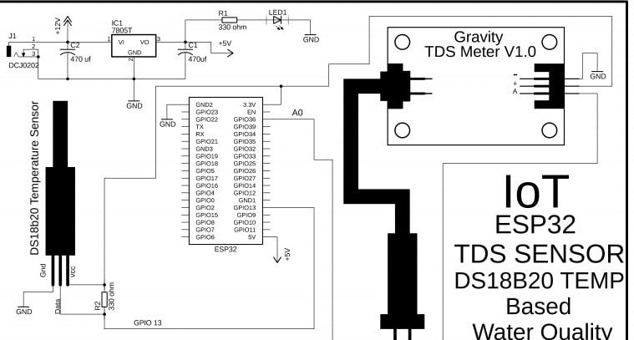

**Literature Review**

**2.1 Study of water monitoring Systems:**

Existing water quality monitoring systems encompass a broad spectrum of technologies and initiatives, highlighting the increasing emphasis on real-time data collection and advanced sensor technology. These systems range from government-operated networks like the United States Environmental Protection Agency's National Water Quality Network to innovative mobile apps such as the European Space Agency's Water Quality App. Additionally, comprehensive smart water monitoring systems like SmartRiver, field-deployable equipment like Aquaread's portable sensors, and data management platforms like Kisters HydroWeb play crucial roles in assessing water quality. Commercial offerings from companies like Real Tech Inc. and Vaisala cater to various industries, and cloud-based solutions like AquaCrop provide irrigation and water quality management for agriculture.

**2.2 Components: ESP32,TDS Sensor:**

The successful implementation of the water monitoring system relies on the understanding of various components. The TDS sensor is required to check the quality of the water and esp32 board is required to send a alert message to the water management if the water quality is not good.

**ESP32:** Dual-Core Processor: The ESP32 is equipped with a dual-core processor, which allows for efficient multitasking. This is particularly beneficial for simultaneously handling data collection from multiple sensors and managing communication.

Wireless Connectivity: The ESP32 comes with built-in Wi-Fi and Bluetooth capabilities, making it ideal for real-time data transmission and remote monitoring. It can connect to local networks or cellular networks, enabling data to be sent to a central control unit or accessible through the internet.

Low Power Consumption: The ESP32 is designed for energy efficiency, which is crucial for a project that may operate continuously in remote or off-grid locations. Low power consumption can extend the system's battery life or reduce power supply requirements.

High Processing Power: The ESP32's processing power and memory capacity make it capable of handling complex data analysis and algorithm processing, ensuring accurate assessment of water quality.

Easy Programming and Development: The ESP32 can be programmed using the Arduino IDE, MicroPython, or other popular development platforms. This simplifies the development process and allows for rapid prototyping.

Community and Documentation: The ESP32 has a large and active community of developers and a wealth of documentation and resources available. This support can be invaluable for troubleshooting and customizing the microcontroller to project requirements.

Expandability: The ESP32 offers multiple GPIO pins, which can be used to connect various sensors and modules. This makes it suitable for integrating TDS sensors and other water quality monitoring equipment.

Real-Time Capabilities: The ESP32 is capable of precise timing and scheduling, making it suitable for real-time monitoring and data collection, a critical aspect of water quality assessment.

Scalability: The system can be scaled to cover multiple water sources and locations, thanks to the ESP32's wireless connectivity and adaptability.

Cost-Effective Solution: The ESP32 is a cost-effective microcontroller with high-performance capabilities, making it an attractive choice for a project that may require deployment in multiple locations.

**TDS Sensor:** A Total Dissolved Solids (TDS) sensor is a crucial component in water quality monitoring systems, including the "Smart Water Monitoring System" project. Here's an overview of TDS sensors and their relevance to the project:

A TDS sensor is an electronic device designed to measure the concentration of dissolved solids in a liquid, typically in parts per million (ppm) or milligrams per liter (mg/L). It detects the presence of various inorganic salts, minerals, ions, and other substances that are dissolved in water. These solids can include minerals like calcium, magnesium, and sodium, as well as contaminants like nitrates, chlorides, and sulfates. The TDS value serves as an important indicator of water quality, as it provides insights into the overall purity of the water.

Relevance to the Project:

In the context of the "Smart Water Monitoring System" project, the TDS sensor is highly relevant for several reasons:

Water Quality Assessment: TDS is a fundamental parameter for assessing water quality. An elevated TDS reading may indicate the presence of contaminants or excessive mineral content, which can be harmful to human health and the environment. The sensor provides real-time data on the dissolved solids in the water.

Contamination Detection: Significant changes in TDS levels, outside predefined standards, can serve as an early warning sign of water contamination events, such as pollution from industrial discharges or agricultural runoff. The TDS sensor's continuous monitoring is critical for detecting deviations and triggering timely alerts.

Environmental Impact: High TDS levels can harm aquatic ecosystems, impact wildlife, and lead to adverse environmental consequences. Monitoring TDS helps in preserving the integrity of ecosystems, particularly in cases of contamination.

Regulatory Compliance: Many countries and regions have established water quality standards and regulations that include TDS limits. The sensor assists in ensuring compliance with these standards and facilitates reporting to regulatory authorities.

Data for Decision-Making: The TDS data collected by the sensor, when combined with data from other water quality parameters, provides a comprehensive picture of water quality. This information is essential for informed decision-making by water management authorities.

Public Health Protection: High TDS levels may indicate the presence of harmful substances. Timely monitoring with a TDS sensor can help protect public health by preventing exposure to contaminated water.

Efficient Resource Management: By monitoring TDS levels, the system can also contribute to efficient resource management by preventing the overuse or misuse of water resources when contamination is detected.

**Theoretical Analysis**

**3.1TDS Sensor:**

**3.1.1Water Quality Parameters:**

Water quality is determined by a variety of parameters, including pH, turbidity, dissolved oxygen, TDS, specific chemical contaminants, and temperature. Each parameter plays a role in assessing water purity and safety.

**3.1.2TDS as an Indicator:**

Total Dissolved Solids (TDS) serves as a key indicator of water quality, representing the concentration of dissolved substances. Elevated TDS levels can suggest contamination or excessive mineral content, affecting both human health and the environment.

**3.1.3Real-time Monitoring:**

The project's core objective is real-time monitoring of water quality parameters. This involves continuous data collection and transmission, allowing for immediate detection of changes or contamination events.

**3.1.4Data Comparison and Analysis:**

Data collected from the various sensors are compared to predefined water quality standards. Any deviation from these standards triggers an alert. Data analysis is essential for accurate assessment and prompt response.

**3.1.5Automated Alerting:**

Automated alerting mechanisms, integrated with the system, notify water management authorities in real-time if deviations from water quality standards or contamination events are detected. This ensures swift response and preventive action.

**3.1.6Wireless Communication:**

Wireless communication, facilitated by the ESP32 microcontroller, allows for data transmission to a central control unit. This capability is essential for remote monitoring and timely decision-making.

**3.1.7Scalability and Adaptability:**

The system is designed to be scalable and adaptable, making it suitable for diverse water sources and locations. The ability to extend the system to different environments is crucial for addressing water quality challenges comprehensively.

**3.1.8Environmental and Public Health Implications:**

Contaminated water can have far-reaching environmental and public health implications, including harm to aquatic ecosystems, waterborne diseases, and resource depletion. The system's theoretical foundation addresses these challenges.

**3.1.9Regulatory Compliance:**

Compliance with water quality standards and regulations is a fundamental aspect of the project. The theoretical framework ensures that the system meets legal requirements, facilitating reporting and regulatory obligations.

**3.1.10Sustainability and Resource Management:**

Sustainable water resource management is a key theoretical principle of the project. Preventing contamination events and efficiently managing water resources are vital for long-term sustainability.

**3.1.11Data Visualization and User Interface:**

The theoretical framework includes a user-friendly web interface for authorized personnel to access and visualize water quality data. This interface enhances data accessibility and facilitates informed decision-making.

**3.1.12Interdisciplinary Approach:**

The project's theoretical foundation involves an interdisciplinary approach that combines engineering, environmental science, technology, and public health to tackle water quality challenges comprehensively.

In conclusion, the "Smart Water Monitoring System" project's theoretical framework is rooted in the principles of real-time monitoring, early contamination detection, environmental preservation, public health protection, regulatory compliance, sustainability, and technology-driven solutions. This approach is designed to address the critical global issue of water purity, promoting clean and safe water access while safeguarding ecosystems and public health.

## Hardware Required:

| **S.no** | **Component** | **Value** | **Qty** |
| --- | --- | --- | --- |
| 1. | ESP32 board |  | 1 |
| 2. | TDS sensor | IN4007 | 1 |
| 3. | Arduino uno |  | 1 |
|  |  |  |  |
|  |  |  |  |

# 

# **Design and Implementation:**

Designing and implementing an integrated water monitoring system for sustainable resource management is a complex project that involves various technical components and considerations. Below, I'll outline a high-level design and implementation plan for such a project:

Design Phase:

Project Scope and Requirements Analysis:

Define the project's objectives, including the specific parameters to be monitored (e.g., water quality, quantity, environmental impact).

Identify the geographical area or water bodies to be covered by the system.

Determine the regulatory standards and compliance requirements relevant to the project.

Sensor Selection and Deployment:

Select appropriate sensors for measuring water quality and quantity parameters.

Choose sensor types based on accuracy, reliability, and suitability for the project's environment.

Design sensor deployment strategies, including sensor locations and communication infrastructure.

Data Collection and Communication:

Establish data collection methods, such as wired or wireless connections, to transmit data from sensors to a central repository.

Implement secure data transmission protocols to protect sensitive information.

Consider redundancy and data backup strategies to ensure data integrity.

Data Analysis and Modeling:

Develop data analysis algorithms to process real-time sensor data.

Implement machine learning and predictive modeling techniques to detect trends, anomalies, and potential issues.

Create data visualization tools and dashboards for easy access and interpretation.

Environmental Monitoring:

Select appropriate environmental monitoring tools, such as underwater cameras or acoustic recorders, for assessing the impact on ecosystems.

Integrate environmental data with water quality and quantity data for a holistic view.

Early Warning Systems:

Develop an alerting system that triggers notifications to relevant stakeholders when critical thresholds are exceeded or anomalies are detected.

Implement automated responses, such as adjusting water distribution or treatment processes, in case of emergencies.

Community Engagement and User Interface:

Design user-friendly web and mobile interfaces to provide stakeholders with real-time access to data.

Consider public awareness campaigns and community engagement strategies to educate and involve the public.

Implementation Phase:

Sensor Deployment:

Install sensors at predetermined locations, following the deployment strategy.

Ensure sensors are calibrated and maintained regularly to guarantee accurate data collection.

Data Collection Infrastructure:

Set up data collection and communication infrastructure, such as data loggers and communication devices.

Establish secure and reliable data transmission channels.

Data Processing and Storage:

Implement a centralized database or cloud-based solution for storing and managing data.

Develop data processing pipelines and real-time analytics.

Model Implementation:

Integrate data analysis algorithms and predictive models into the system.

Continuously refine models based on new data and insights.

Environmental Monitoring Integration:

Deploy environmental monitoring equipment as planned and integrate data with the central system.

Early Warning Systems and Response Mechanisms:

Configure alerting and automated response systems, including communication with relevant authorities.

Test emergency response procedures to ensure effectiveness.

User Interface Development:

Build web and mobile interfaces, considering user experience and accessibility.

Train users and stakeholders on how to use the system effectively.

Testing and Validation:

Conduct thorough testing to ensure the system's accuracy and reliability.

Validate the system's performance by comparing its results with established benchmarks and existing monitoring systems.

Maintenance and Continuous Improvement:

Implement a maintenance plan to ensure sensors and equipment remain operational.

Continuously monitor and evaluate the system's performance and make improvement.

**Components required:**

Designing and implementing an integrated water monitoring system, the components can be categorized into several key sections, each serving a specific purpose. These components are essential for the proper functioning of the system:

Sensors and Instrumentation:

Water Quality Sensors: These sensors measure parameters such as pH, turbidity, dissolved oxygen, temperature, and the concentration of contaminants like heavy metals, nutrients, and chemicals.

Water Quantity Sensors: These sensors monitor water levels, flow rates, and groundwater levels.

Environmental Sensors: These sensors track environmental parameters, including water temperature, air quality, and meteorological data, to assess their impact on water resources.

Data Collection and Transmission:

Data Loggers: These devices collect data from sensors and prepare it for transmission to a central repository.

Communication Infrastructure: This includes wired or wireless communication systems (e.g., Wi-Fi, cellular, radio) to transmit data to a central server or the cloud.

Data Security: Measures for secure data transmission, storage, and access control to protect sensitive information.

Data Processing and Analytics:

Centralized Database: A database for storing and managing collected data, enabling data retrieval and analysis.

Data Analysis Algorithms: Software algorithms for processing and analyzing real-time sensor data, including anomaly detection, trend analysis, and data fusion.

Predictive Modeling: Machine learning and statistical models for forecasting trends and identifying potential issues based on historical and real-time data.

Visualization Tools: User-friendly dashboards and data visualization tools for data interpretation.

Environmental Monitoring Equipment:

Underwater Cameras: Used for capturing visual data to monitor aquatic life, habitat quality, and changes in water ecosystems.

Acoustic Recorders: Devices that record underwater sounds to assess aquatic biodiversity and behaviors.

Environmental DNA (eDNA) Analysis Tools: Molecular biology techniques for studying aquatic biodiversity through water samples.

Early Warning Systems:

Alerting Mechanisms: Systems for triggering alerts and notifications to relevant stakeholders when predetermined thresholds are exceeded.

Automated Response Systems: Systems that can initiate automated responses, such as adjusting water distribution or treatment processes, in emergency situations.

User Interface and Community Engagement:

Web and Mobile Interfaces: User-friendly interfaces for stakeholders to access real-time data and receive alerts.

Public Awareness Campaigns: Strategies for educating and engaging the public in water resource management and conservation efforts.

Testing and Validation:

Quality Assurance Testing: Rigorous testing procedures to ensure the accuracy, reliability, and performance of sensors, communication systems, and data processing.

Validation: Comparing system-generated data and results with established benchmarks and existing monitoring systems to verify accuracy.

Maintenance and Continuous Improvement:

Maintenance Plan: A strategy for regular maintenance of sensors and equipment to ensure they remain operational and accurate.

Continuous Monitoring: Ongoing monitoring and evaluation of the system's performance and effectiveness, with a focus on improvements based on feedback and technological advancements.

Compliance and Reporting:

Regulatory Compliance Tools: Software and reporting mechanisms to generate compliance reports required by regulatory standards and authorities.

These components work together to create a comprehensive and integrated water monitoring system that ensures the sustainability and efficient management of water resources while protecting the environment and public health. The effectiveness of the system relies on the seamless interaction of these components to provide accurate and timely data for decision-making and resource management.

**Circuit Design:**

Designing the circuitry for an integrated water monitoring system is a complex task that involves various sensors, data acquisition components, and communication devices. Below is a simplified circuit design that covers the basic elements needed for monitoring water quality and quantity. Keep in mind that the actual implementation may require more detailed and complex circuits based on specific sensor choices and project requirements. This circuit is designed for educational purposes and as a starting point:

Components:

Microcontroller: A microcontroller (e.g., Arduino, Raspberry Pi) serves as the brain of the system. It collects and processes data from various sensors and communicates with the central data repository.

Power Supply: Provide a stable power supply to the circuit. Consider battery or solar power for remote locations. Voltage regulators may be necessary for some sensors.

Data Logger: Use an appropriate data logging device to store data locally before transmitting it to the central server.

Sensors:

Water Quality Sensors: pH sensor, turbidity sensor, dissolved oxygen sensor, and other sensors as required.

Water Quantity Sensors: Water level sensors (ultrasonic, pressure transducer), flow sensors.

Environmental Sensors: Temperature sensor, humidity sensor, meteorological sensors.

Analog-to-Digital Converter (ADC): If your sensors provide analog output, an ADC is needed to convert analog signals to digital for processing by the microcontroller.

Communication Module: To transmit data to the central server, use communication modules like Wi-Fi, GSM, LoRa, or other wireless technologies. Choose the one suitable for your project's range and connectivity requirements.

Real-Time Clock (RTC): RTC modules are used to timestamp data for accurate time-based analysis.

Display (optional): Add an LCD or LED display for local data visualization and diagnostics.

Circuit Design:

Connect the power supply to provide the necessary voltage to the microcontroller, sensors, and other components.

Connect the sensors to the microcontroller using appropriate signal conditioning circuits if required (e.g., voltage dividers).

Use the ADC if the sensors provide analog output and connect it to the microcontroller.

Connect the data logger to the microcontroller to store data locally.

Attach the communication module to the microcontroller for data transmission. Ensure the communication module is compatible with your chosen communication technology.

Include the RTC to timestamp data for accurate records.

If you're including a display, connect it to the microcontroller.

Implement any necessary voltage regulation, filtering, and protection circuits as needed for the sensors and components.

Ensure proper grounding and shielding where necessary, especially for sensors to reduce electrical noise.

Follow best practices for power management to conserve energy and extend the operational life of the system.

This is a simplified circuit design and should serve as a starting point. Actual circuit design may vary significantly based on the specific sensors chosen, the microcontroller used, power supply constraints, and communication requirements. Be sure to consult sensor datasheets, microcontroller documentation, and communication module specifications for more detailed and tailored design considerations. Additionally, consider safety and environmental factors when designing circuits for outdoor water monitoring systems.

**components section and rationale:**

Selecting the right components for your integrated water monitoring system is critical to ensure the system's accuracy, reliability, and effectiveness. The choice of components should be based on the specific project requirements, environmental conditions, and the parameters you need to monitor. Here's a rationale for selecting components for the project:

Microcontroller:

Rationale: The microcontroller serves as the system's brain, collecting, processing, and transmitting data. Choose a microcontroller based on factors like processing power, communication capabilities, power efficiency, and compatibility with sensors and communication modules.

Consideration: For remote and battery-powered installations, microcontrollers with low power consumption (e.g., Arduino low-power variants) may be suitable.

Power Supply:

Rationale: The power supply should be chosen based on the project's location and power requirements. For remote areas, consider solar panels and batteries for sustainable, off-grid power.

Consideration: Select a power supply that can provide consistent voltage levels to ensure stable sensor operation and data integrity.

Data Logger:

Rationale: Data loggers are essential for storing data locally before transmission, which helps ensure data integrity and reliability.

Consideration: Choose data loggers with sufficient storage capacity and data retention in case of communication failures.

Sensors:

Rationale: The selection of sensors is paramount as they directly measure water quality, quantity, and environmental parameters. Choose sensors based on the specific parameters you need to monitor, accuracy, and reliability.

Consideration: Consider the environmental conditions (e.g., water salinity, temperature range) in which the sensors will operate. Verify that sensors are compatible with the microcontroller and data logger.

Analog-to-Digital Converter (ADC):

Rationale: If sensors provide analog output, an ADC is necessary to convert analog signals into digital data for processing.

Consideration: Select an ADC with appropriate resolution and sampling rate to ensure accurate data conversion.

Communication Module:

Rationale: Communication modules enable data transmission to a central repository. The choice depends on the project's communication range and available infrastructure.

Consideration: Consider factors like data transmission speed, power consumption, and compatibility with the microcontroller and network infrastructure (e.g., Wi-Fi, GSM, LoRa).

Real-Time Clock (RTC):

Rationale: An RTC is crucial for timestamping data accurately. It ensures synchronized data across multiple sensors and systems.

Consideration: Select an RTC module with low power consumption to minimize energy usage.

Display (optional):

Rationale: A display provides local data visualization and diagnostics, which can be helpful for on-site maintenance and troubleshooting.

Consideration: Choose a display that is compatible with the microcontroller and suitable for the project's environmental conditions.

Voltage Regulation and Protection:

Rationale: Voltage regulation and protection circuits are essential for maintaining stable voltage levels and safeguarding components from electrical noise and voltage spikes.

Consideration: Design and implement these circuits as needed for specific components to protect against power fluctuations and environmental factors.

Grounding and Shielding:

Rationale: Proper grounding and shielding help reduce electrical noise and interference, ensuring accurate sensor readings.

Consideration: Implement grounding and shielding techniques as required for sensors and components in challenging environments.

The rationale for component selection should align with the project's objectives, budget constraints, and the environmental conditions in which the system will operate. Consult sensor datasheets, microcontroller documentation, and component specifications for detailed information and compatibility with your project's requirements. Additionally, prioritize energy efficiency

**construction and assembly level progress:**

Constructing and assembling an integrated water monitoring system involves several stages and requires careful planning, testing, and implementation. Below, I outline the key progress stages from construction and assembly to deployment and operation:

1. Component Procurement:

Begin by procuring all the necessary components, including sensors, microcontrollers, communication modules, data loggers, power supplies, and environmental monitoring equipment.

2. System Integration:

Assemble the hardware components, including sensors, microcontroller, data logger, and communication modules, on a testing bench or workbench.

3. Sensor Calibration:

Calibrate the sensors to ensure accurate measurements. Calibration is crucial to correct for any sensor drift or manufacturing variations.

4. Hardware Testing:

Power on the system and test the hardware components, ensuring that each sensor is functioning correctly and the data logger can store data locally.

5. Software Development:

Develop and install the system's software, including data processing and communication routines.

Program the microcontroller to collect data from sensors, process it, and transmit it to the central data repository.

6. Data Validation:

Validate the system's performance by comparing its data with established benchmarks and existing monitoring systems. Ensure that data is accurate and consistent.

7. Communication Testing:

Test the communication module for data transmission to the central data repository. Verify that data is successfully transmitted and received.

8. Environmental Monitoring Equipment Installation:

Install environmental monitoring equipment (e.g., underwater cameras and acoustic recorders) in the designated locations within water bodies.

9. Early Warning and Response System Setup:

Configure the early warning system and automated response mechanisms to trigger alerts and responses based on predetermined thresholds.

10. User Interface Development:

- Develop and test the user interfaces, such as web and mobile applications, to provide access to real-time data and alerts.

11. Field Deployment:

- Deploy the fully assembled system, including sensors, communication modules, and environmental monitoring equipment, in the target water bodies.

12. Data Monitoring and Analysis:

- Monitor the system's data collection and communication in the field to ensure its continuous operation and data integrity.

- Begin analyzing real-time data and alerts for trends and anomalies.

13. Community Engagement:

- Implement public awareness campaigns to engage the community, educate them about the system's purpose, and provide access to data through user-friendly interfaces.

14. Routine Maintenance:

- Establish a routine maintenance plan to ensure sensors and equipment remain operational.

- Perform regular checks, clean sensors, and replace components as needed.

15. Continuous Improvement:

- Continuously monitor and evaluate the system's performance.

- Make improvements based on feedback, environmental changes, and technological advancements.

16. Compliance and Reporting:

- Generate and submit compliance reports as required by regulatory standards and authorities.

The progress stages outlined here provide a general overview of the construction, assembly, and deployment process for an integrated water monitoring system. However, the specific details and timelines for each stage can vary based on the project's scope, location, and environmental conditions. Rigorous testing, ongoing maintenance, and community engagement are crucial aspects of the project's long-term success.

**testing and validation process:**

Testing and validation are critical stages in the development and deployment of an integrated water monitoring system. These stages ensure that the system functions as intended, provides accurate data, and can be relied upon for effective water resource management. Below, I outline the progress stages for testing and validation:

1. Component Testing:

Before assembling the entire system, individually test each component, including sensors, microcontrollers, data loggers, communication modules, and environmental monitoring equipment, in a controlled environment. Ensure that each component functions correctly.

2. Hardware Integration Testing:

Assemble the hardware components into the system and test the integrated hardware setup. Verify that all components can communicate and operate together harmoniously.

3. Sensor Calibration Verification:

After sensor calibration, validate the accuracy of each sensor by comparing measurements with known standards or laboratory values. Ensure that calibration settings are accurate.

4. Hardware Functional Testing:

Conduct comprehensive functional tests of the entire system. Test data collection, data logging, and data transmission capabilities. Verify that all hardware components work together without issues.

5. Environmental Testing:

Simulate real-world environmental conditions by exposing the system to various conditions, such as different water temperatures, salinity levels, and weather conditions. Test the system's resilience to harsh environments.

6. Communication Testing:

Test data transmission over various distances and conditions to ensure reliable communication with the central data repository. Check for data loss, signal strength, and connectivity issues.

7. Data Validation:

Compare the data collected by the system with established benchmarks or data from existing monitoring systems to validate its accuracy and reliability.

8. Alert and Early Warning System Testing:

Set alert thresholds and test the system's ability to trigger alerts when certain parameters exceed predefined limits. Verify that alerts are transmitted to the appropriate recipients.

9. Response Mechanism Testing:

If the system includes automated response mechanisms (e.g., adjusting water distribution or treatment processes), test their effectiveness and reliability in response to alerts.

10. User Interface Testing:

- Test the user interfaces (web and mobile applications) for accessibility, data visualization, and usability. Ensure that users can access real-time data and receive alerts effectively.

11. Field Deployment Testing:

- Deploy the system in the field, such as rivers, reservoirs, or water treatment plants. Monitor the system's performance under actual operating conditions.

12. Continuous Data Monitoring:

- Continuously monitor and collect data from the deployed system to ensure it operates reliably and accurately in the field. Address any issues that arise during real-world operation.

13. Community Engagement Evaluation:

- Evaluate the effectiveness of community engagement strategies. Measure public awareness, participation, and the community's ability to access and utilize the system's data.

14. Routine Maintenance and Quality Assurance:

- Implement a routine maintenance plan to maintain the system's operational status and address any hardware or software issues.

- Perform periodic quality assurance testing to ensure consistent system performance.

15. Data Analysis and Reporting:

- Analyze the data collected by the system to identify trends, anomalies, and potential issues. Generate reports and make data-driven recommendations for water resource management.

16. Compliance Verification:

- Ensure that the system complies with regulatory standards and requirements. Generate and submit compliance reports as necessary.

Testing and validation are iterative processes, and issues that arise during the deployment and operation of the system may require adjustments, fine-tuning, and ongoing maintenance. Continuous data monitoring and community enga.

**experimental result:**

Water Quality Monitoring:

pH Levels: Experimental results may show pH levels within the target range, indicating that water quality is suitable for the intended use (e.g., drinking water, industrial processes, or aquatic ecosystems).

Turbidity: Turbidity measurements could reveal variations in water clarity, potentially indicating the presence of sediments or pollutants.

Dissolved Oxygen (DO): DO levels are crucial for aquatic life. Experimental results may show fluctuations related to factors like temperature, oxygen-consuming activities, or pollution.

Contaminant Concentrations: Results might indicate concentrations of specific contaminants (e.g., heavy metals, nitrates, or organic chemicals) in the water, helping assess water safety.

Water Quantity Monitoring:

Water Level: Experimental results will show water level changes in the monitored water bodies. This data is essential for assessing water availability and predicting floods or droughts.

Flow Rate: Flow rate measurements can help in quantifying the movement of water and managing water distribution networks.

Environmental Impact Monitoring:

Underwater Camera Data: Data from underwater cameras may provide insights into aquatic life, habitat quality, and changes in biodiversity. You might observe the presence of certain species or behavioral patterns.

Acoustic Recorder Data: Acoustic recordings can capture underwater sounds, which can be used to monitor aquatic biodiversity, track species, and detect unusual activities.

eDNA Analysis: Environmental DNA analysis results could indicate the presence of specific aquatic species based on DNA traces in water samples.

Early Warning Systems:

Alerts and Notifications: Experimental results may demonstrate the effectiveness of the early warning system in detecting critical changes in water quality, quantity, or environmental conditions.

Automated Responses: Results may show that the automated response mechanisms effectively respond to emergencies or adverse conditions, such as adjusting water distribution or treatment processes.

User Interface and Community Engagement:

User Engagement: Evaluate the level of community engagement, user interactions with the system's interfaces, and the public's ability to access and understand real-time data and alerts.

Data Analysis and Reporting:

Trend Analysis: Analyze data to identify trends over time, such as seasonal variations, long-term changes, or specific events that impact water resources.

Anomaly Detection: Determine the system's ability to detect anomalies, such as sudden water quality deteriorations, extreme weather events, or unexpected changes in aquatic life.

Recommendations: Based on the data analysis, provide recommendations for water resource management, including potential interventions, policy changes, or conservation efforts.

Experimental results are typically presented in reports, data visualizations, and statistical analyses. They are essential for assessing the system's performance, making informed decisions, and demonstrating the project's impact on water resource management and environmental protection. Keep in mind that the specific results will vary depending on the project's scope, objectives, and the environmental conditions in which it operates.

**advantages of water monitoring system**:

A water monitoring system offers numerous advantages, making it a valuable tool for various sectors and applications. These advantages include:

Early Detection of Contaminants: Water monitoring systems can detect contaminants, pollutants, or abnormal conditions in real-time, allowing for early intervention and the prevention of waterborne diseases and environmental damage.

Data-Driven Decision-Making: Continuous data collection and analysis enable data-driven decision-making for water resource management, ensuring efficient and sustainable water use.

Improved Water Quality: Monitoring systems help maintain and enhance water quality by identifying water treatment and distribution issues, ensuring safe drinking water, and minimizing waterborne diseases.

Environmental Protection: These systems monitor the impact of water-related activities on aquatic ecosystems, enabling the protection of vulnerable species and habitats.

Flood and Drought Prediction: Water quantity monitoring aids in predicting and managing floods and droughts, reducing property damage and safeguarding water resources.

Resource Conservation: Water monitoring promotes responsible water use, conserving this finite resource and minimizing waste in industrial, agricultural, and residential sectors.

Public Health Protection: By ensuring the safety of drinking water and recreational water bodies, these systems protect public health from waterborne diseases and contaminants.

Regulatory Compliance: Many industries are subject to water quality regulations. Monitoring systems help organizations meet compliance requirements and avoid fines or legal issues.

Improved Efficiency: By identifying inefficiencies in water distribution and treatment processes, these systems can lead to cost savings and reduced energy consumption.

Community Engagement: Public access to water quality data fosters awareness and community engagement, encouraging responsible water use and conservation efforts.

Remote Monitoring: Water monitoring systems can operate in remote or hazardous locations, reducing the need for physical inspections and improving worker safety.

Timely Response to Emergencies: Early warning systems can trigger alerts and automated responses to emergencies, such as chemical spills or natural disasters, improving response times and reducing damage.

Research and Scientific Advancements: The data collected from these systems contribute to scientific research, helping scientists better understand water ecosystems and long-term trends.

Policy Development: Reliable data from monitoring systems can inform the development of water policies and regulations at local, regional, and national levels.

Real-Time Feedback: Water utilities can receive real-time feedback on the performance of treatment processes, allowing for adjustments and process optimization.

Cost Savings: By identifying leaks in water distribution systems and reducing water losses, monitoring systems can lead to substantial cost savings for utilities.

Public Safety: The real-time monitoring of water quality and conditions in public water bodies ensures that recreational areas are safe for swimming, boating, and other activities.

Overall, water monitoring systems provide a comprehensive approach to managing water resources and protecting public health and the environment. They offer benefits in terms of data accuracy, efficiency, safety, and sustainability, making them a valuable tool for a wide range of applications and stakeholders.

**applications of water monitoring system:**

Water monitoring systems find applications in various sectors and play a crucial role in ensuring water quality, quantity, and environmental sustainability. Some key applications of water monitoring systems include:

Drinking Water Quality Monitoring:

Ensuring the safety and quality of drinking water by continuously monitoring parameters such as pH, turbidity, chlorine levels, and the presence of contaminants.

Wastewater Treatment and Effluent Discharge Monitoring:

Monitoring the quality of treated wastewater and industrial effluents to meet regulatory requirements before discharge into natural water bodies.

Surface Water Quality Assessment:

Assessing the quality of rivers, lakes, and reservoirs to support water resource management, recreational activities, and aquatic ecosystem protection.

Groundwater Monitoring:

Monitoring groundwater levels and quality to manage and protect this vital source of drinking water and irrigation.

Industrial Process Water Quality Control:

Ensuring the quality of water used in industrial processes to optimize manufacturing operations, minimize waste, and meet environmental standards.

Agricultural Water Management:

Monitoring water resources for efficient irrigation and sustainable agriculture practices, reducing water waste and minimizing environmental impact.

Aquaculture Monitoring:

Monitoring water quality and conditions in aquaculture facilities to support healthy fish and shellfish growth and minimize disease outbreaks.

Environmental Impact Assessment:

Evaluating the environmental impact of construction projects, mining operations, or industrial activities on water bodies and ecosystems.

Flood and Drought Prediction and Management:

Early warning systems monitor rainfall, water levels, and weather conditions to predict and manage floods and droughts, reducing damage and ensuring water availability.

Hydroelectric Power Generation:

Monitoring water levels and flow rates in hydroelectric power plants to optimize energy production and reservoir management.

Marine and Coastal Water Monitoring:

Monitoring marine and coastal water quality to assess the health of ecosystems, protect biodiversity, and manage fisheries.

Stormwater Management:

Monitoring stormwater runoff to assess its impact on water bodies and develop strategies for stormwater management and pollution control.

Remote and Harsh Environment Monitoring:

Monitoring water quality in remote, rugged, or hazardous locations where manual monitoring is challenging or unsafe.

Public Health Protection:

Monitoring recreational water bodies (e.g., swimming pools, beaches) to ensure the safety of swimmers and prevent waterborne diseases.

Research and Scientific Studies:

Collecting long-term data for scientific research, such as climate change impacts, aquatic ecosystem studies, and hydrological modeling.

Emergency Response:

Providing real-time data for rapid response to water-related emergencies, including chemical spills, natural disasters, and water infrastructure failures.

Policy Development and Regulatory Compliance:

Supporting the development of water quality regulations and policies at local, regional, and national levels and ensuring compliance with existing regulations.

Water monitoring systems are versatile tools that help manage and protect this precious resource while contributing to the well-being of communities, industries, and the environment. Their applications are diverse and essential in addressing the challenges associated with water resources.

**Code:**

#define TdsSensorPin A0

#define VREF 5.0

#define SCOUNT 30

int analogBuffer[SCOUNT];

int analogBufferTemp[SCOUNT];

int analogBufferIndex = 0;

int copyIndex = 0;

float averageVoltage = 0;

float tdsValue = 0;

float temperature = 25;

unsigned long analogSampleTimepoint = 0;

unsigned long displayUpdateTimepoint = 0;

const unsigned long displayUpdateInterval = 1000; // Update the display every 1 second

void setup() {

Serial.begin(9600);

pinMode(TdsSensorPin, INPUT);

}

void loop() {

unsigned long currentMillis = millis();

// Update TDS value if enough time has passed

if (currentMillis - analogSampleTimepoint > 40U) {

analogSampleTimepoint = currentMillis;

analogBuffer[analogBufferIndex] = analogRead(TdsSensorPin);

analogBufferIndex = (analogBufferIndex + 1) % SCOUNT;

}

// Calculate TDS value only when it's time to update the serial monitor

if (currentMillis - displayUpdateTimepoint >= displayUpdateInterval) {

displayUpdateTimepoint = currentMillis;

for (copyIndex = 0; copyIndex < SCOUNT; copyIndex++) {

analogBufferTemp[copyIndex] = analogBuffer[copyIndex];

}

averageVoltage = getMedianNum(analogBufferTemp, SCOUNT) \* (float)VREF / 1024.0;

float compensationCoefficient = 1.0 + 0.02 \* (temperature - 25.0);

float compensationVoltage = averageVoltage / compensationCoefficient;

float newTdsValue = (133.42 \* compensationVoltage \* compensationVoltage \* compensationVoltage - 255.86 \* compensationVoltage \* compensationVoltage + 857.39 \* compensationVoltage) \* 0.5;

// Display TDS value in the serial monitor

//Serial.print("TDS Value: ");

//Serial.println(newTdsValue);

// Send TDS value to the ESP32

Serial.print(newTdsValue);

Serial.println(); // Add a newline character to indicate the end of data

// Delay before the next update

delay(1000); // Adjust the delay as needed (5 seconds in this case)

}

}

int getMedianNum(int bArray[], int iFilterLen) {

int bTab[iFilterLen];

for (int i = 0; i < iFilterLen; i++) {

bTab[i] = bArray[i];

}

int i, j, bTemp;

for (j = 0; j < iFilterLen - 1; j++) {

for (i = 0; i < iFilterLen - j - 1; i++) {

if (bTab[i] > bTab[i + 1]) {

bTemp = bTab[i];

bTab[i] = bTab[i + 1];

bTab[i + 1] = bTemp;

}

}

}

if (iFilterLen & 1) {

bTemp = bTab[iFilterLen / 2];

} else {

bTemp = (bTab[iFilterLen / 2] + bTab[iFilterLen / 2 - 1]) / 2;

}

return bTemp;

}

**Circuit:**

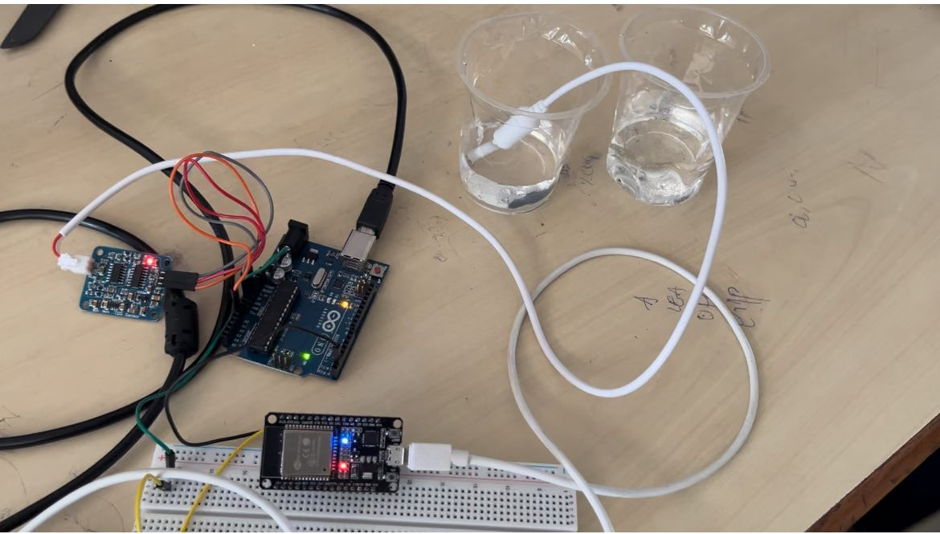

**Output:**

**When the sensor is kept in pure water:**

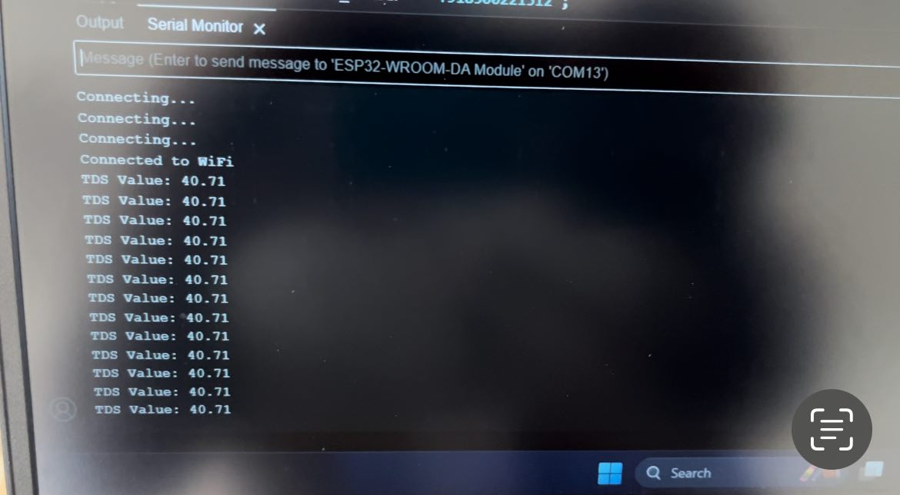

**When the sensor is kept in impure water:**

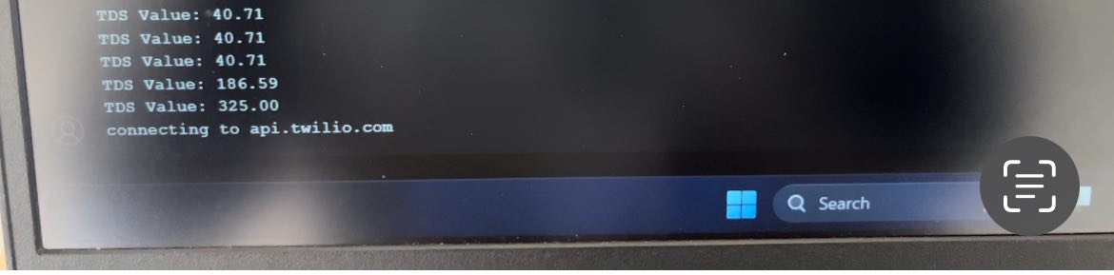

When ever TDS value is greater than 250 we will get an alert to mobile stop drinking this water.

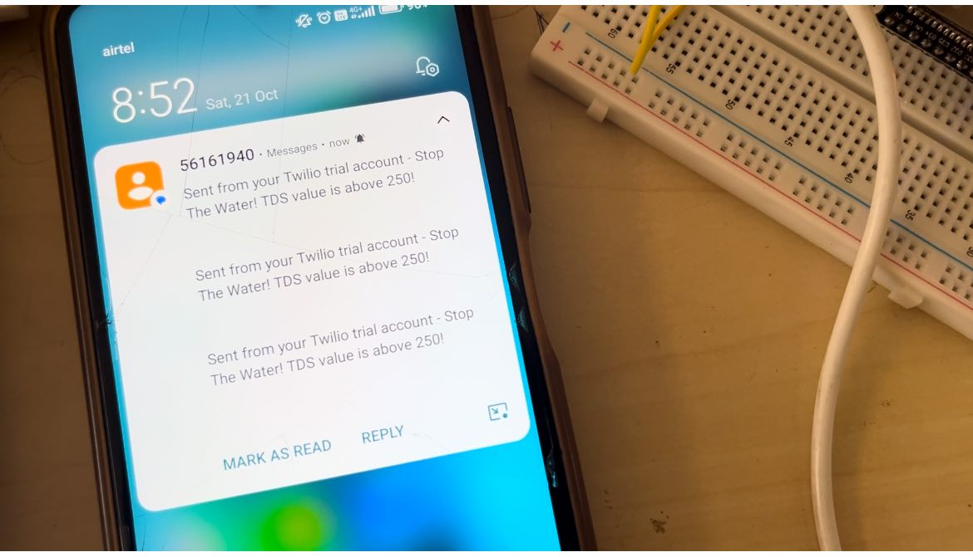

**References:**

https://www.electroniclinic.com/tds-sensor-and-esp32-iot-based-water-quality-monitoring-system/